##### Questions:

**WHERE:**

1. Thestudentcounsellorwantedtodisplaytheregistrationnumber,studentnameanddateofbirthfor allthestudents.
2. Thecontrollerofexaminationswantedtolistallthefemalestudents
3. Whoaretheboystudents registeredforcoursewiththecoursenumber“C001“
4. Displayallfacultydetailsjoinedbefore “November2014”
5. Displayallthecoursesnotallotted tohalls

##### LIKE:

1. Listthestudentswhosename endswiththesubstring“ma”
2. Displayallstudentswhosenamecontainsthesubstring“ma”
3. Findallthestudentswhoare locatedincitieshaving“Sal”assubstring
4. Displaythestudentswhosenamesdonotcontainsixletters.
5. Findallthestudentswhosenamescontains “th”

##### OUTPUTS:

1)

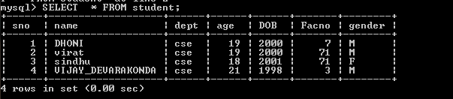

2)

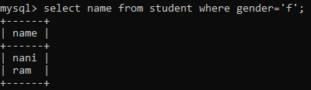

3)

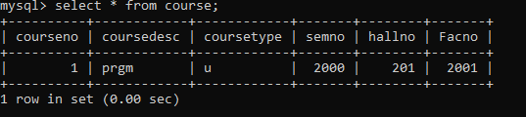

4)



5)

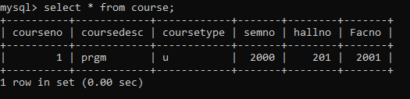

6)



7)



8)



9)



10)

